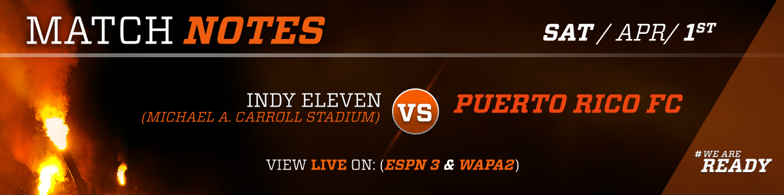
0-1-0  H 0-1-0  A 0-0-0 | 0-1-0  H 0-0-0  A 0-1-0
Previous Match

0-0 vs New York Cosmos | 1-1 at San Francisco Delta
League Table- Spring Season | Team Leaders 2016
P Team Pld Pts  1 Indy Eleven 1 1  2 Miami FC 1 1  3 North Carolina FC 1 1  4 San Francisco Deltas 1 1  5 New York Cosmos 1 1  6 Puerto Rico FC 1 1  7 FC Edmonton 0 0  8 Jacksonville Armada FC 0 0 | Goals:  Hector Ramos 8  Assists:  Héctor Ramos 4  Minutes:  Cristiano Dias/ Ramón Soria 1890  Passing Accuracy:  Michael Kafari 81%

Storylines:
Season Opener against the Cosmos 3/25/17: It was a very physical match between the two clubs, and it was especially contested in midfield where PRFC showcased three of its newest additions: Yuma, Jairo Puerto and Walter Ramírez, along with Michael Kafari who is in his second year with the team. Puerto stood out from the start using his speed to relentlessly attack the sidelines. It was this attacking mindset what set the tone for the match in which PRFC outshot the Cosmos 14 to 5 even though New York controlled the possession. In the first half Héctor “Pito” Ramos had one of the best scoring opportunities of the game when he received a cross from Kyle Culbertson but his kick went wide right. In the second half, it was another Puerto Rican national who had a chance to score, this time it was Mike Ramos who received a cross from Puerto but his header went over the crossbar. In the last minute of the game Trevor Spangenberg proved to be the hero once again when he stopped a Cosmos shot right in front of him that kept the match tied.
Last year on the road: Puerto Rico FC finished the 2016 season with a 2-4-5 record. The two victories came in the second half of the season in which PRFC was unbeaten in eight of the 11 matches. The first was a 1-0 nail-biting win against Miami FC and the second a 2-1 victory against Ottawa Fury.
Caribbean Club Championship: PRFC hosted Group D of the Caribbean Club Championship. In their first match, they defeated SV Transvaal from Suriname 1-0. In the second match, they faced Portmore United from Jamaica in a game that was tied 0-0 heading into the 88th. A goal by Portmore broke PRFC’s seven game unbeaten streak. In the third match of the tournament PRFC defeated Scholars International 4-0 but was eliminated when Portmore defeated SV Transvaal earlier that day.
Versus Indy Eleven- PRFC’s inaugural game was a 1-1 tie at home against Indy. Puerto Rico had the lead going into the 90th minute thanks to a Héctor “Pito” Ramos goal. A Souleymane Youla header in stoppage time rescued the tie for the Eleven. The story was different when PRFC travel to Indy in the 21st week of the Fall Season. Even though Indy had a playoff spot secured, they were playing for home field advantage and scored three goals in the first 45 minutes. PRFC played a lot better in the second half but the whole was too deep to climb out off.
Yuma Team of the Week: PRFC hosted the Cosmos in their 2017 home opener at Juan Ramón Loubriel Stadium. The match was extremely hard fought in the midfield and Yuma was key in keeping the defending champions scoreless. The Spaniard’s admirable defensive prowess was evident from the start. He intercepted three passes and fought for every loose ball. He also proved to be an important part of the attack restarting an offense that outshot their opponent 14 to 5.
Puerto Rico FC previous four games (2-1-1):
Vs New York Cosmos 0-0
Starting XI
PRFC: Trevor Spangenberg, Cristiano Dias (C), Kyle Culbertson, Rudy Dawson, Conor Doyle, Héctor Ramos, Jairo Puerto, Walter Ramirez, Michael Kafari, Yuma, Tyler Rudy.
NYC: Jimmy Maurer, Ryan Ritcher, Carlos Mendes, Andrea Mancini, Andres Flores, Danny Szetela, Amauri, Juan Guerra, Ayoze, Irvin Herera, Darrius Barnes.
Goals:  None  Yellow Cards:  None | Substitutions:  PRFC:  75' Michael Ramos por Connor Doyle  81' Ramón Soria por Michael Kafari  87' Sidney Rivera por Jairo Puerto  NYC:  56' Jimmy Mulligan por Irvin Herrera  60' Kalif Alhassan por Andrea Mancini  72' Eugene Starikov por Amauri

Vs Scholars International 4-0
Starting XI
PRFC: Austin Pack, Cristiano Dias (C), Ramon Soria, Jordi Quintanilla, Brian Bement, Jacob Stovall, Michael Ramos, Walter Ramirez, Seth Moses, Sidney Rivera, Yuma.
SISC: Jermaine Brown (c), Cesar Fajardo, Thomas Elliot, Dwight Dunk, Damalay Howell, Michael Brown, Rolly Bodden, James Ebanks, Jorge Escobar, Jamar Dickens, Jermaine Haughton.
Goals:  PRFC:  13' Michael Ramos  34' Sidney Rivera  50' Brian Bement  56' Cristiano Dias  Yellow Cards:  SISC:  81' Jorge Escobar | Substitutions:  PRFC:  53' Jackie Marrero for Walter Ramirez  SISC:  73' Rodrick Pearson for Jamar Dickens  78' Rex Bush for Michael Brown

VS Portmore United FC 0-1
Starting XI
PRFC: Trevor Spangenberg; Kyle Culbertson, Ramon Soria (C), Rudy Dawson, Jordi Quintanilla, Conor Doyle, Hector Ramos, Giussepe Gentile, Michael Kafari, Yuma, Tyler Rudy

PUFC: Shaven-Sean Paul; Damono Solomon, Kareen Manning, Andre Dyce, Ricardo Morris, Tramaine Stewart, Ewan Grandison (C), Jermie Lynch, Cleon Pryce, Henrico Ricketts, Michael Binns
Goals:  PUFC:  88' Ricardo Morris  Yellow Cards:  PRFC:  41' Yuma  48' Kyle Culbertson  81' Jordi Quintilla  PUFC:  14' Tramaine Stewart  81' Kareem Manning | Substitutions:  PRFC:  66' Joseph Marrero for Javier Monsalvez  89' Sidney Rivera for Connor Doyle  89' Cristiano Dias for Giussepe Gentile  PUFC:  70' Javon East for Jermie Lynch  74' Maalique Foster for Cleon Price  90' Ryan Wellington for Ricardo Morris

Vs SV Transvaal 1-0
Starting XI
PRFC: Trevor Spangenberg; Kyle Culbertson, Cristiano Dias (c), Rudy Dawson, Conor Doyle, Hector Ramos, Giussepe Gentile, Walter Ramirez, Michael Kafari, Yuma, Tyler Rudy.
SVT: Cherwin Doorson; Fernando Felix, Jerry Boldewlin, Sorencio Juliaans (c), Ivenzo Comvalius, Debolha Akoela, Sean Cooper, Jude Sunday, Cleandro File, Clevon McFee, Erin Tjon A Loi
Goals  PRFC:  Hector "Pito" Ramos 26' (P)  Yellow Cards  PRFC:  36' Kyle Cubertson  44' Michael Kafari  73' Tyler Rudy  SVT:  21' Fernando Felix  26' Cherwin Doorson  89' Ervin Tjon A Loi | Substitutions  PRFC:  71' Jackie Marrero por Walter Ramires  81' Jordi Quintilla por Michael Kafari  SVT:  67' Alessandro Ferreira por Debolha Akoela  81' Victorinio Pinas por Ivenzo Comvalius

Puerto Rico FC Schedule and Results
Spring Season
3/25/2017 | 7:30 | Vs | New York | Juan Ramón Loubriel Stadium | 0-0
4/1/2017 | 3:00 | At | Indy | Michael A Carroll Stadium
4/8/2017 | 7:30 | Vs | Indy | Juan Ramón Loubriel Stadium
4/22/2017 | 9:00 | At | Edmonton | Clarke Field
4/29/2017 | 7:30 | Vs | North Carolina | Juan Ramón Loubriel Stadium
5/6/2017 | 7:30 | Vs | Miami | Juan Ramón Loubriel Stadium
5/13/2017 | 7:00 | At | New York | MCU Park
5/20/2017 | 7:30 | Vs | North Carolina | Juan Ramón Loubriel Stadium
5/27/2017 | 7:30 | At | Miami | FIU Stadium
6/3/2017 | 7:30 | Vs | Edmonton | Juan Ramón Loubriel Stadium
6/10/2017 | 7:30 | Vs | San Francisco | Juan Ramón Loubriel Stadium
6/16/2017 | 7:30 | At | New York | MCU Park
6/25/2017 | 6:00 | At | Jacksonville | Hodges Stadium
7/2/2017 | 8:30 | At | San Francisco | Kezar Stadium
7/8/2017 | 7:30 | Vs | Jacksonville | Juan Ramón Loubriel Stadium
7/15/2017 | TBD | At | North Carolina | WakeMed Soccer Park
Fall Season
7/29/2017 | TBD | At | North Carolina | Wake Med Sccer Park
8/5/2017 | 7:30 | Vs | Jacksonville | Juan Ramón Loubriel Stadium
8/12/2017 | 7:30 | Vs | San Francisco | Juan Ramón Loubriel Stadium
8/16/2017 | 6:30 | At | Jacksonville | Hodges Stadium
8/20/2017 | 4:00 | At | Edmonton | Clarke Field
8/26/2017 | 7:30 | Vs | Miami | Juan Ramón Loubriel Stadium
9/2/2017 | 7:30 | At | Miami | FIU Stadium
9/9/2017 | 7:30 | Vs | New York | Juan Ramón Loubriel Stadium
9/16/2017 | TBD | At | North Carolina | WakeMed Soccer Park
9/20/2017 | 7:30 | Vs | Edmonton | Juan Ramón Loubriel Stadium
9/23/2017 | 7:30 | At | Indy | Michael A. Carroll Stadium
9/30/2017 | 7:30 | Vs | New York | Juan Ramón Loubriel Stadium
10/7/2017 | 7:30 | Vs | North Carolina | Juan Ramón Loubriel Stadium
10/14/2017 | 10:00 | At | San Francisco | Kezar Stadium
10/21/2017 | 7:30 | Vs | Indy | Juan Ramón Loubriel Stadium
10/28/2017 | 7:00 | At | New York | MCU Park

Staff
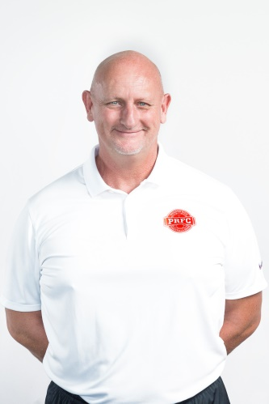
Neil Sillett/ Technical Director | Adrian Whitbread/ Head Coach
Neil Sillett is a former player, coach and current Technical Director of Puerto Rico FC. Over the past two decades he has worked for Portsmouth FC, Coventry City FC and Derby County FC. He has a proven track record in recognizing quality players and throughout his career has helped develop many players into stars in England’s Premier League. | Adrian Whitbread is a former professional soccer player and current manager of Puerto Rico FC. He played at all levels of English soccer and started his managerial career as an assistant for Barnet FC. He moved on to clubs such as Brentford FC, Milton Keynes Dons FC, and Leicester City before joining the Puerto Rico Islanders where he eventually became the Head Coach. Before going back to Puerto Rico to join PRFC he managed Antigua Barracuda FC, Bahrain’s Olympic National Team, and Barnet FC as an assistant once more.
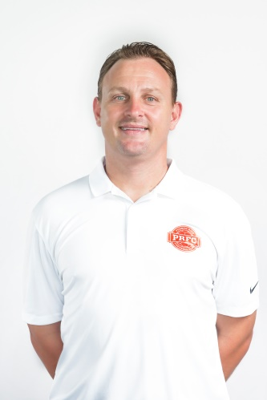 | 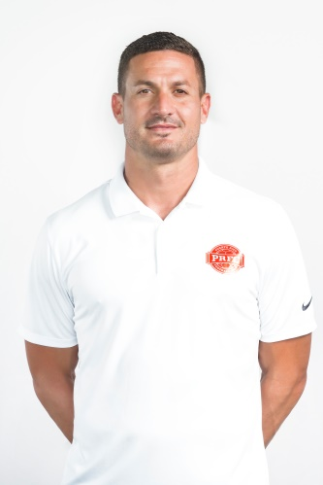
Jack Stefanowski  First Assistant/ GK Coach | Marco Vélez  Second Assistant

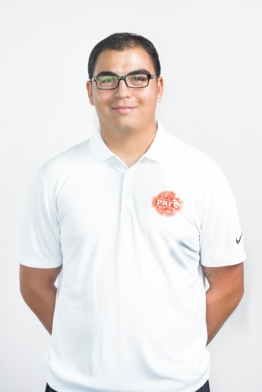 | 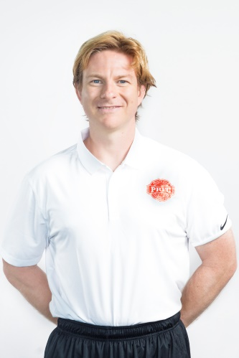 | 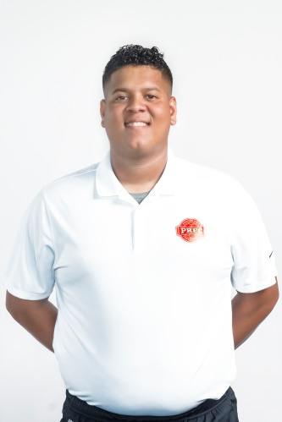
Kevin Indart  Athletic Trainer | Nicky Kirk  Chiropractor | Abner Santana  Equipment Manager

Puerto Rico FC Roster
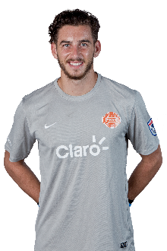 | #1 Austin Pack  Goalkeeper  6’2”  180 lbs  Alpharetta, GA | 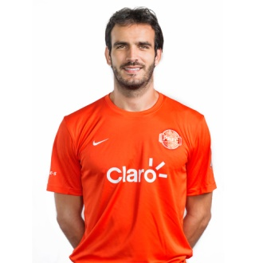 | #2 Cristiano Dias  Center Back  6’3”  192 lbs  Minas Gerais, BR
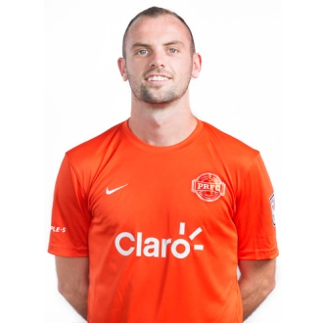 | #3 Kyle Culbertson  Left Back  5’11”  160 lbs  Columbus, OH | 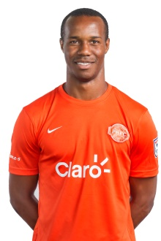 | #4 Rudy Dawson  Center Back  5’9”  170 lbs  5/8/1988  Limón, CRC
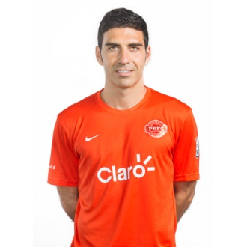 | #5 Ramón Soria  Center Back  5’9”  168 lbs  Alicante, ESP | 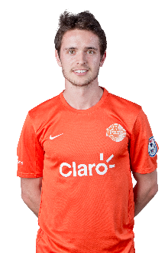 | #6 Jordi Quintillà  Center Midfield  5’9”  154 lbs  Lérida, ESP
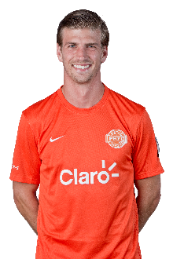 | #8 Conor Doyle  Center Midflied  6’2”  172 lbs  MicKinney, TX | 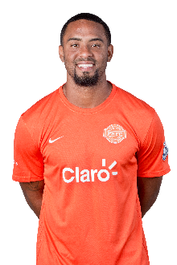 | #9 Héctor Ramos  Forward  6’3”  190 lbs  Maunabo, PR
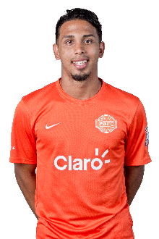 | #10 Joseph Marrero García  Left Wing  5’8”  145 lbs  San Juan, PR | 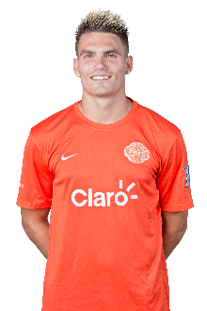 | #11 Giuseppe Gentile  Forward  6’  165 lbs  USA
 | #12 Emery Welshman  Forward | 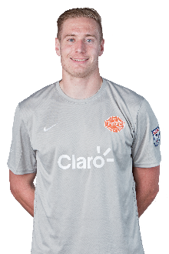 | #13 Billy Thompson  Goalkeeper  6’6”  168 lbs  California, USA
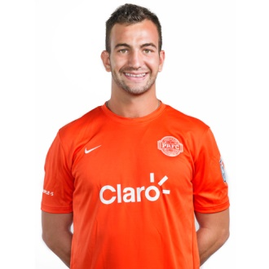 | #14 Brian Bement  Center Midfield  6’0”  180 lbs  Waterloo, IL | 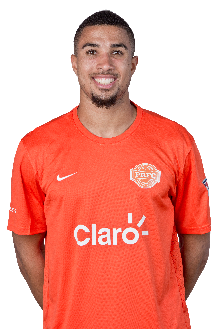 | #16 Michael Ramos  Forward  6’1”  Washington, USA
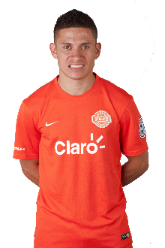 | #17 Jairo Puerto  Right Wing  5’7”  Honduras | 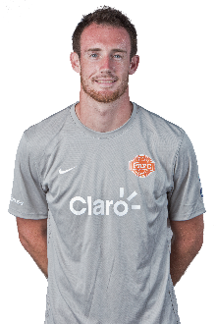 | #18 Trevor Spangenberg  Goalkeeper  6’3”  190 lbs  Valparaiso, IN
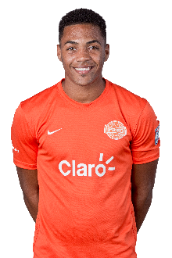 | #19 Jorge Rivera  Winger  6’0”  157 lbs  San Juan, PR | 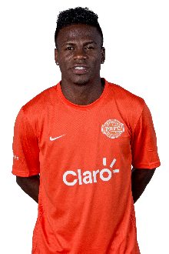 | #20 Walter Ramírez  5’9”  150 lbs  Honduras
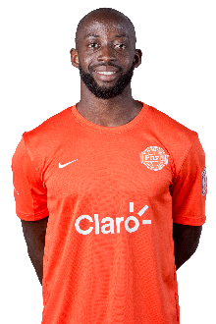 | #21 Michael Kafari  Center Midfield  6’1”  175 lbs  Ghana | 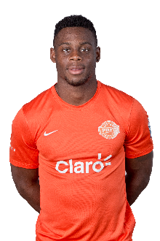 | #22 Seth Moses  Right Back  5’8”  Baltimore, USA
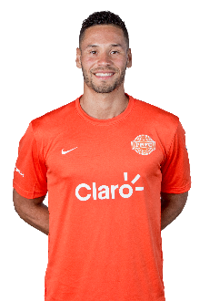 | #23 Sidney Rivera  Forward  6’2”  185 lbs  Staten Island, NY | 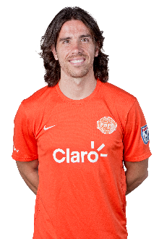 | #24 Yuma  Center Midfield  5’9”  150 lbs  Madrid, ESP
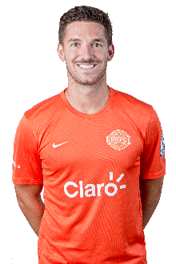 | #29 Tyler Rudy  Right Back  5’10”  160 lbs  Olney, MD

About the players
# | Position | Name | Column1
1 | GK | Austin Pack | Named Defensive Player of the Week three times and recorded eight shutouts in 2014 for UNC Charlotte.
2 | CB | Cristiano Dias | Has played for Miami FC and Minnesota United. Won the USL title in 2011 with MNU FC. Second year Captain of PRFC.
3 | LB | Kyle Culbertson | Product of Columbus Crew Academy. Flew to Puerto Rico for PRFC's open trial and stood out immediately. Nominated for NASL's Young Player of the Year. Scored one goal and 3 assists as a rookie.
4 | CB | Rudy Dawson | Member of the 2012 Costa Rican Olympic National team and played for one of the biggest teams in his country, Deportivo Alajuelense.
5 | LB | Ramón Soria | Played for the Spain National Team at the U16, U17 and U19. Also played in UEFA Europa League with Villareal FC. Played 1890 minutes last year at RB, CB and CDM.
6 | CM | Jordi Quintillà | Played for Barcelona B, Ajaccio of France and Sporting Kansas City.
8 | CM | Conor Doyle | Played in Derby County of England and DC United of MLS. Represented U20 of USA and U21 of Ireland.
9 | F | Héctor Ramos | Played in El Salvador with Metapán and CD Aguila then moved on to Saudi Arabia.Scored 18 goals with PR National Team and was responsible for 12 of PRFC’s goals last year.
10 | W | Joseph Marrero | Six goals for PR National Team. Nominated for NASL's Young Player of the Year award.
11 | F | Giuseppe Gentile | Played for Orlando City B, Chicago Fire, Chiasso of Switzerland, Fort Lauderdale Strikers and Ottawa Fury.
13 | GK | Billy Thompson | 2014 PDL Goalkeeper of the Year.
14 | CM | Brian Bement | Won the Horizon League with Loyola University and started in all 21 matches of his senior year scored four goals throughout. Second year with PRFC.
15 | CB | Jake Stovall | Drafted by Seattle Sounders in third round of MLS Super Draft.
16 | F | Michael Ramos | Drafted by Toronto FC of MLS but signed with PDL team Kitsap Pumas then loaned to Seattle Sounders FC 2. Scored his first goal with the Puerto Rico National Team against Curazao.
17 | W | Jairo Puerto | Played in Real España, Olimpia and Marathon, three of the clubs in Honduras scoring 12 goals and winning 2 titles/ In 2017 was part of the Honduras National Team that became Champions of Central America.
18 | GK | Trevor Spangenberg | Drafted by Chivas USA in 2014 and signed next season with New England Revolution. NCAA's lowest goal average against in 2013. Won the job in Week 11 last season against FC Edmonton. Started 12 of 22 games.
19 | W | Jorge Rivera | His first appearance with PR National Team in 2015 and scored his first goal in 2016 against Anguilla. Two goals with PRFC in Copa Luis Villarejo in 2016.
20 | W | Walter Ramírez | One of the most experienced players in the NASL playing with Tampa Rowdies, Fort Lauderdale Strikers, Indy Eleven and San Antonio Scorpions. 8416 minutes played.
21 | M | Michael Ramos | He is a native of Accra in Ghana. While at University of New Mexico he caught the eye of the MLS scouts and was selected by the Vancouver Whitecaps. More recently played for FK Ostersunds in Sweden.
22 | RB | Seth Moses | Joined Swiss USV Eschew Mauren in 2011. Came back to USA with Baltimore Bohemians. Moved on to K-League with FC Anyang.
23 | F | Sidney Rivera | Drafted by Orlando City SC in 2015. MVP for Old Dominion University in 2014 and Conference USA offensive MVP. Scored three crucial goals for PRFC last season. Nominated for NASL's Young Player of the Year.
24 | CDM | Yuma | Played for Rayo Vallecano and Salamanca of Spain. In 2016 played for Rayo OKC of the NASL.
29 | CDM | Tyler Rudy | Started in DC United academy winning two youth MLS Cups. Ranked 3rd best senior in the Big East Conference during senior year season and in 2015 signed with New England Revolution. Scored first professional goal against Rayo OKC last season. Has been converted from CDM to Right Back.
Roster and Pronunciations
# | Position | Name | Last Name | Nickname | Pronunciation
1 | GK | Austin | Pack | A-Pack
2 | CB | Cristiano | Dias | Cristiano | Dee-as
3 | LB | Kyle | Culbertson
4 | CB | Rudy | Dawson
5 | CB | Ramón | Soria |  | SO-reea
6 | CM | Jordi | Quintillà |  | Keen-TeeJAH
8 | CM | Conor | Doyle
9 | F | Héctor | Ramos | Pito | Rah-moss
10 | W | Joseph | Marrero | Jackie | Mah-reh-roh
11 | F | Giuseppe | Gentile | Giussi | Joo-SEH-pee Gen-TEAL-eh
12 | W | Emery | Welshman
13 | GK | Billy | Thompson
14 | CM | Brian | Bement
15 | CB | Jake | Stovall
16 | F | Michael | Ramos | Mike | Rah-moss
17 | W | Jairo | Puerto |  | Hi-roh Pooerto
18 | GK | Trevor | Spangenberg | T-Rev
19 | W | Jorge | Rivera | Georgie | Ree-vera
20 | W | Walter | Ramírez |  | Rah-mee-ress
21 | CM | Michael | Kafari |  | Kah-Fah-ree
22 | RB | Seth | Moses |  | Moe-sess
23 | F | Sidney | Rivera | Sid the Kid | Ree-vera
24 | CDM | Yuma |  |  | U-mah
29 | RB | Tyler | Rudy

